# Bearing calculation description

## Flowchart

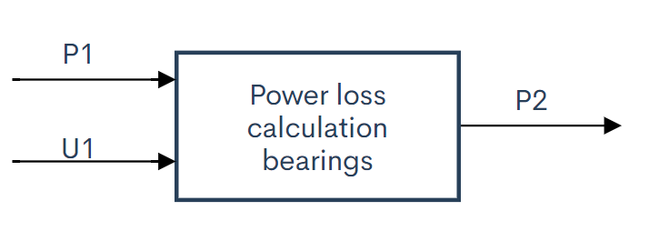

## Functions

* Calculate power loss for different bearings.

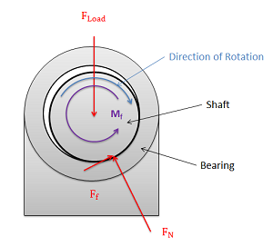

(Moore)

$$F_{friction}=F_{load}*µ$$

$$P=T*ω$$

$$T=F_{friction}*r_{shaft}$$

$$P_{out}=P_{in}-\left(\left(F_{friction}*r_{shaft}\right)*ω\right)$$

|  |  |
| --- | --- |
| Bearing Type | Coefficient of friction µ |
| Deep Groove Ball Bearing | 0,0015 |
| Angular Contact Bearing | 0,0020 |
| Cylindrical Roller Bearing, Cage | 0,0010 |
| Cylindrical Roller Bearing, Full Comp. | 0,0020 |
| Tapered Roller Bearing | 0,0020 |
| Spherical Roller Bearing | 0,0020 |
| Ball Thrust Bearing | 0,0015 |
| Cylindrical Roller Thrust Bearing | 0,0050 |
| Tapered Roller Thrust Brg. Cage | 0,0020 |
| Tapered Roller Thrust Brg. Full Comp | 0,0050 |

(FRICTION & FREQUENCY FACTORS, sd)

|  |  |  |  |  |
| --- | --- | --- | --- | --- |
| Interaction | Symbol | Min. | Max. | Unit |
| -> P1 | | | | |
| Simulation inputs |  |  |  |  |
| Power input from motor | $$P_{in}$$ | 0 | 8400 | W |
| Rotational speed | $$n$$ | 0 | 2200 | rpm |
| Torque | T | 0 | 3500 | Nm |
| <- P2 |  |  |  |  |
| Simulation outputs |  |  |  |  |
| Power loss | $$P_{loss}$$ | 0 | 1 | $$\% of P_{in}$$ |
| Power output | $$P_{out}$$ | 0 | 8316 | W |
| -> U1 |  |  |  |  |
| User inputs |  |  |  |  |
| Friction coefficient | µ | 0,0015 | 0,0050 |  |
| Radius shaft | r | 0 | 0,05 | M |
| Load | $$F_{load}$$ | 0 | 1000 | N |